PARISH ADMINISTRATOR
Job Description

Job Title | Parish Administrator
Parish | St Swithun Wells Parish
Location | Holy Cross Parish Office, Leigh Road, Eastleigh, SO50 9DF
Hours of Work | Part-time 15 hours per week over 3 days, working pattern to be agreed at interview
Salary | £9,523.80 per annum (FTE £23,809.50)
Contract Type | Permanent
Reports To | Parish Priest
Number of Reports | None

- Overall Job Purpose
St Swithun Wells Parish is seeking a Parish Administrator. The Parish Administrator provides comprehensive administrative and organisational support to the Parish Priest, ensuring the smooth day-to-day operations of the parish. This role enables the Parish Priest to focus on pastoral duties while maintaining efficient administrative processes.
As an employee of the Catholic Diocese of Portsmouth, the Parish Administrator must adhere to all Diocesan policies and procedures, as well as any local arrangements authorised by the Parish Priest.

- Key Internal and External Relationships
- Parish Priest
- Priests and Deacons across the Pastoral Area
- Parish volunteers and employees
- Parishioners and visitors
- Diocesan Curia departments (Finance, HR, Estates, Safeguarding, Communications, and Governance)
- External suppliers and contractors

- Main responsibilities
General Administration
- Provide administrative support to the Parish Priest and clergy.
- Maintain and update parish records, including parishioner databases, sacramental registers, and schedules.
- Prepare and distribute the weekly Parish Newsletter.
- Handle general inquiries, phone calls, emails, and correspondence professionally.
- Manage diaries and appointments for the Parish Priest, Assistant Priest, and pastoral visits.
- Assist in coordinating pastoral activities and parish events.
- Ensure all registers are up to date and maintain accurate documentation for sacraments.
- Support parish groups and sacramental preparation programs, including managing course materials.
- Coordinate funeral and wedding bookings, including diary management.

Parish Communication & Liaison
- Act as the first point of contact for parishioners, visitors, and external inquiries, either in person, via telephone or email, ensuring a welcoming and professional response.
- Support the Parish Priest in coordinating meetings, events, and pastoral initiatives.
- Ensure effective communication between the parish and diocesan departments, submitting reports and compliance documents as required.

Sacramental & Liturgical Support
- Schedule and coordinate baptisms, weddings, funerals, and other sacramental celebrations, ensuring all necessary documentation is completed.
- Prepare mass sheets and liturgical documents for Christmas, Easter, and other key celebrations.

Governance & Compliance
- Ensure compliance with data protection regulations (GDPR) and maintain secure and well-organised records.
- Assist in implementing diocesan policies, including safeguarding procedures and governance protocols.

Other Responsibilities
- Work collaboratively with parish volunteers, offering support and training where required.
- Undertake other reasonable ad-hoc tasks as requested by the Parish Priest.

- Professionalism & Values
- Uphold and promote the ethos and values of the Catholic Church.
- Work collaboratively with clergy, employees, and volunteers to support the parish mission.
- Foster a welcoming and professional parish environment for all.
- Maintain confidentiality and discretion in all aspects of the role.

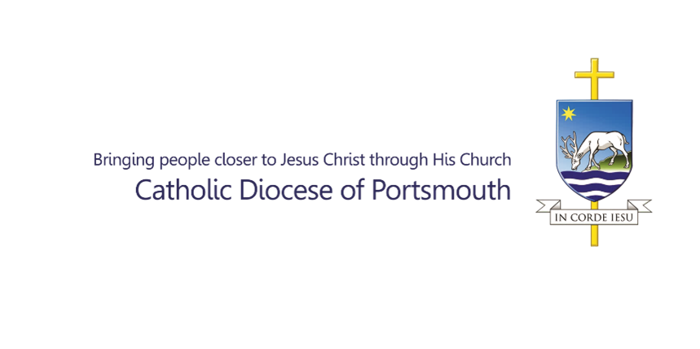
PARISH ADMINISTRATOR
Person Specification

Competence, Expertise and Knowledge:
Essential | - IT proficiency, including Microsoft Office Suite (Word, Excel, Outlook, PowerPoint) and database management.  - Strong organisational skills, with the ability to prioritise multiple tasks effectively.  - Excellent written and verbal communication skills, ensuring professional interaction with parishioners and external stakeholders.  - Previous administrative experience, in a busy office with a keen eye for detail and accuracy.  - Valid UK Right to Work.
Desirable | - Familiarity with the Catholic Church, its teachings, and liturgical practices.  - Experience working in a parish, charity, or faith-based environment.  - Knowledge of safeguarding and data protection best practices.

Date of Completion of Job Description: | 03/10/2025
Job Description Content Creator: | Amber Sochor

