PARISH FINANCE ADMINISTRATOR
Job Description

Job Title | Parish Finance Administrator
Parish | St Swithun Wells Parish
Location | Based at Holy Cross Parish Office, Leigh Road, Eastleigh, SO50 9DF
Hours of Work | 30 hours per week
Salary | £20,800 per annum (FTE £26,000)
Contract Type | MATERNITY LEAVE
Reports To | Parish Priest: Fr Raffaele Cossa
Number of Reports | 0

- Job Purpose
St Swithun Wells Parish is seeking a Parish Finance Administrator. To provide financial management for the parish, ensuring sound stewardship of resources and effective support to the Parish Priest in the administration of the parish.
The postholder is expected to foster a professional, welcoming, and efficient parish environment for parishioners, volunteers, and visitors.
The Catholic Diocese of Portsmouth is a registered charity. Employees working in parishes are formally employed by the Diocese of Portsmouth and must comply with all diocesan policies and procedures, as well as those related to local arrangements specifically authorised by the Parish Priest.

- Key Internal and External Relationships
- Parish Priest
- Priests and Deacons across the Pastoral Area
- Parish volunteers and employees
- Parishioners and visitors
- Diocesan Curia departments (Finance, HR, Estates, Safeguarding, Communications, and Governance)
- External suppliers and contractors

- Main Duties
Parish and Clergy Financial Management
- Liaise with and provide financial information to the Diocesan Finance team as required.
- Prepare and manage the parish budget for approval by the Parish Priest and Finance Committee.
- Prepare quarterly accounts and reports for Finance Committee meetings and attend these meetings.
- Maintain accurate and up-to-date financial records, including income, expenditure, and bank reconciliation using the approved Diocesan Finance System (currently Xero).
- Oversee the collection, counting, and banking of offertory and other parish income, ensuring proper procedures are followed.
- Raise and process invoices, payments, and reimbursements using Xero in a timely and accurate manner.
- Make Bacs payments using CBO security protocols.
- Arrange licences and manage invoices for Parish church halls.
- Prepare monthly reconciliation of accounts and annual financial reports for the Parish Priest and Finance Committee, ensuring transparency and compliance with diocesan requirements.
- Prepare monthly income statements: stipend/expenses/mileage/funerals.
- Assist in tax returns for clergy and collation of data for tax returns.
- Identify Stole Fee payments into main account for Parish Secretary.
- Ensure compliance with diocesan policies for clergy payments and oversee the monthly processing of income and expenses, including banking and recording funeral fees for clergy.
- Support the Parish Priest in fundraising and stewardship initiatives, including second collections, campaigns, and appeals.
- Promote and ensure the routine availability of digital giving platforms for donors, including online and planned giving routes.
- Supervise Parish counting and collection teams, assisting with bank deposits where necessary.
Gift Aid
- Liaise with the Parish Gift Aid coordinators and provide support.
- Ensure all gift aid is claimed regularly.
Property Management
- Liaise with Letting agents, Property Managers, Diocese Estates team and Contractors regarding investment properties and site visits.
- Notify the Estates Department regarding insurance-related matters.
Car Park Administration
- Invoice business users for use of parish car parks (currently Holy Cross and St Swithun Wells).
- Register and issue fobs for Barrier at Holy Cross.
- Liaise with gate supplier in event of any IT malfunctions or gate faults.
Governance and Compliance
- Ensure compliance with all diocesan policies.
- Maintain an asset register and full inventory, ensuring appropriate insurance coverage for parish properties and equipment.
- Assist the parish priest in preparing reports and documentation for diocesan audits and reviews.
Volunteer Coordination
- Provide support and guidance to parish volunteers involved in finance.
- Organise and oversee rotas for volunteers assisting with financial tasks.
Other Responsibilities
- Answer telephone and take messages for the Parish Secretary and clergy.
- Archiving and safe disposal of parish documentation beyond retention dates, in compliance with diocesan retention policy.
- Manage and deal with insurance claims.
- CCTV management.
- Order church supplies.
- Order stationary supplies.
- Liaise with IT support and comms companies to rectify faults: phones, IT equipment, CCTV, barrier gate digital devices, halls.
- Manage appropriate CCLI licensing for 6 parish churches for music activities held.
- Assist in the preparation of reports for parish meetings, including the Parish Finance Committee and Parish Pastoral Council.
- Attend Finance Committee and Parish Pastoral Council meetings and take meeting minutes.
- Provide general administrative support to the Parish Priest as required.
- Undertake any other reasonable duties as requested by the Parish Priest.
- Maintain confidentiality and exercise discretion.

- Professionalism and values
- Uphold and promote the ethos and values of the Catholic Church.
- Work collaboratively with the Parish Administrator and other key members of the parish to ensure the Parish Priest is effectively supported.
- Foster a welcoming and professional parish environment for clergy, volunteers, and parishioners.
- Maintain confidentiality and discretion.

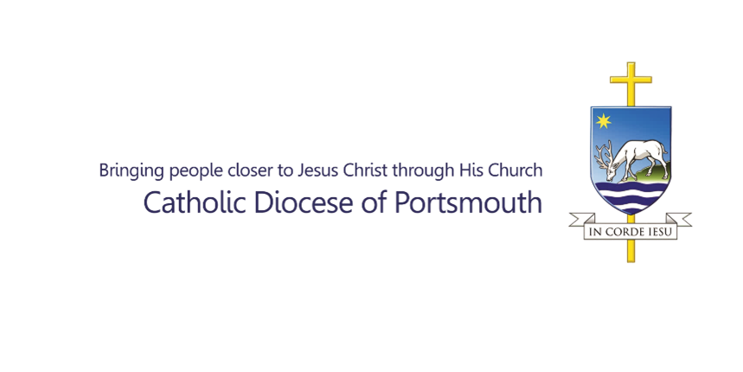
PARISH FINANCE ADMINISTRATOR
Person Specification

Essential Competence, Expertise and Knowledge:
Essential | - Proven experience in financial administration, budgeting, and record-keeping.  - Strong organisational and problem-solving skills, with the ability to manage multiple priorities.  - High level of proficiency in IT, including Microsoft Office and financial software.  - Excellent communication and interpersonal skills, with the ability to engage with people at all levels.  - Valid UK Right to Work.
Desirable | - Formal qualification in financial management, bookkeeping, or accounting.  - Expertise in using Xero.  - Experience working in a parish, charity, or non-profit organisation.  - Understanding of safeguarding and data protection practices.  - Knowledge of the values and teachings of the Catholic Church.  - Familiarity or willingness to learn diocesan policies and procedures.  - Valid driving licence and access to a vehicle.

Date of Completion of Job Description: | March 2026
Job Description Author: | Amber Sochor

